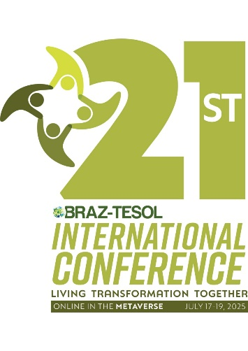**THIS FORM MUST NOT BE MODIFIED. YOU CAN ALSO SEND PROPOSALS FOR PRESENTATIONS IN PORTUGUESE.**

**Proposal Title (*Max 80 characters with spaces)*:**

**Format (Please select just one option with an X):**

( ) **Individual Talk (30 minutes) -** A standard conference presentation. Share classroom practices, reflections, research, or projects in ELT. Sessions may include theoretical elements but must highlight practical relevance. Leave 3–5 minutes for Q&A.

( ) **Panel (25 minutes) -** Two or more speakers (minimum 2 – maximum 4 participants) present different perspectives on the same topic. Panels must be coordinated and cohesive, with clear thematic links and time for audience questions.

( ) **Round Table (25 minutes) -** An open dialogue between a small group of speakers (minimum 2 – maximum 6). Speakers each contribute equally to a topic discussion, with the goal of exchanging ideas rather than delivering formal presentations.

( ) **Two Sides of the Same Coin (25 minutes) -** Two presenters share contrasting views, approaches, or experiences on the same issue. The format allows space for dialogue, comparison, and possibly debate. Both voices must be balanced.

( ) **Guided Discussion (25 minutes) -** The presenter acts as a facilitator, posing 1–2 guiding questions and encouraging attendees to share opinions or experiences. Not a lecture — this is meant to spark meaningful participant interaction.

( ) **Workshop (45 minutes) -** Hands-on, practical, and interactive. Workshops must involve participant engagement throughout — group tasks, mini-projects, roleplay, etc. Avoid lecture-based delivery.

( ) **Demonstration (45 minutes) -** Walk participants through an activity or sequence of activities they can apply in their own contexts. A demonstration shows *how* something works rather than just talking *about* it.

**Topic (Please select just one option with an X):**

( ) Assessment

( ) Bilingual Education

( ) Educational Technologies

( ) English for Professional and Academic Purposes

( ) Intercultural Language Education

( ) Materials Writing

( ) Mind, Brain and Education

( ) Pronunciation

( ) Public School

( ) Teacher Development

( ) Young Learners and Teens

**I would like to be considered for a SIG Showcase. ( ) YES ( ) NO**

**Abstract**

Maximum 300 words

Font: Arial 10pt

Spacing: 1.5

**Objectives**

2 to 3 learning goals

Maximum 200 words

Font: Arial 10pt

Spacing: 1.5

**Contributions & themes to be addressed**

Maximum 250 words

Font: Arial 10pt

Spacing: 1.5

**Keywords**

Maximum 4

**Bibliographical References**

Maximum 5

**Originality Declaration**

Is this an original presentation for the 21st BTIC? ( ) YES ( ) NO

If not, please describe where and when it was delivered.